## Model and GIS Data Availability

Our best model in this area looks like this (for reference, this is sfb_dfm_v2):

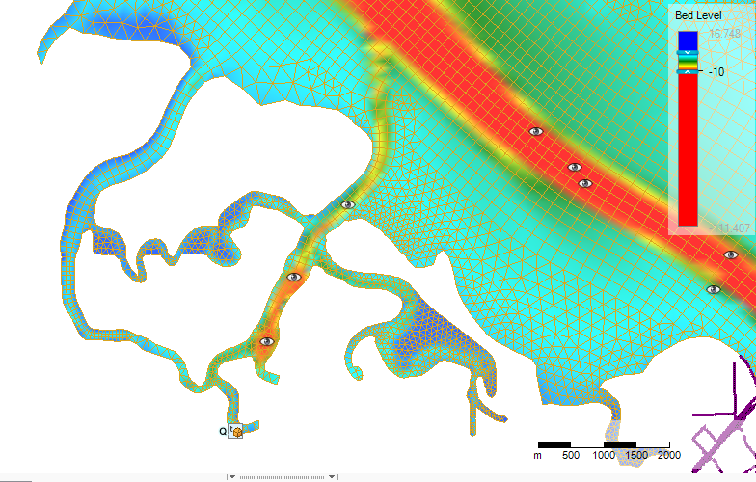

Very little of the intertidal and wetland is captured.

## USGS 2m Topobathy

Seems pretty good, and no real obvious places where the LiDaR is contaminated by standing water.

This is a merged LiDaR/sonar/other DEM, mostly assembled by USGS.

(I:/BASELAYERS/Elevation_DerivedProducts/LiDAR 2005-2012 entire Bay Area from AECOM/USGS_TopoBathy/San_Francisco_TopoBathy_Elevation_2m.tif)

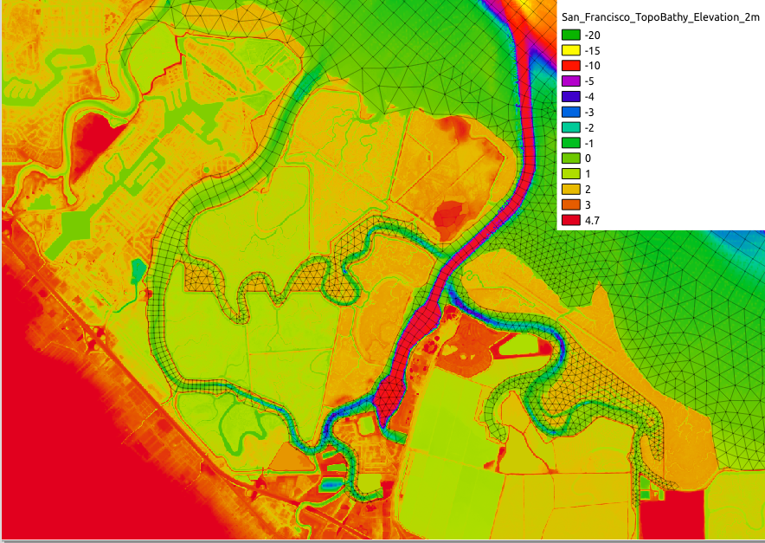

Zoomed in to see more of the high intertidal detail:

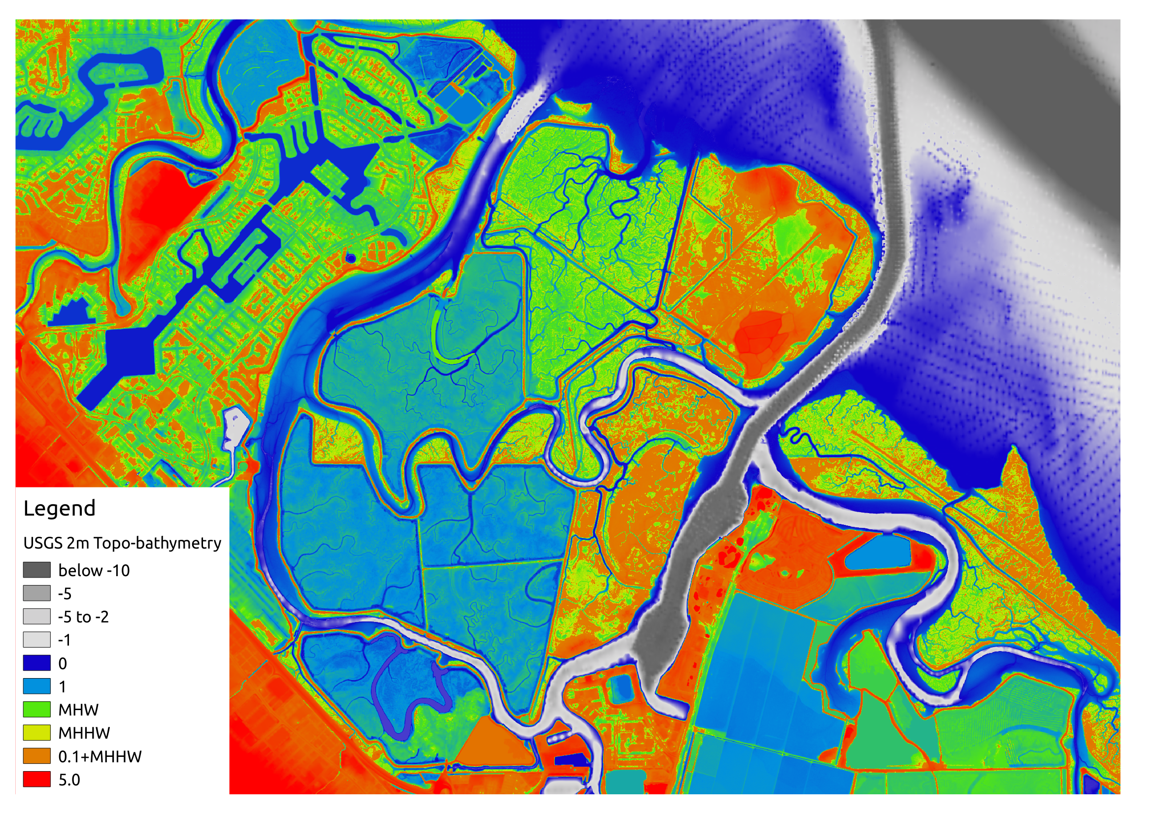

## Tidal Data

[Redwood City tide gage](https://tidesandcurrents.noaa.gov/datums.html?id=9414523).

This gage has no tie-in to NAVD88, but I imagine it would be pretty close to use a MSL-NAVD88 comparison from Alameda. The model calculates that MSL at Redwood City is 1.5cm higher than MSL at Alameda.

[Alameda MSL](https://tidesandcurrents.noaa.gov/datums.html?id=9414750) is 2.067 STND, with NAVD88 of 1.086 STND, or MSL=0.981 m NAVD88

That makes Redwood City MSL 0.996 m NAVD88, and STND is 2.396 m below NAVD88.

MHHW is 4.551

|  |  |  |
| --- | --- | --- |
|  | STND | NAVD88 |
| MHHW | 4.551 | 2.155 |
| MHW | 4.358 | 1.962 |
| MSL | 3.392 | 0.996 |
| MLW | 2.416 | 0.020 |
| MLLW | 2.050 | -0.346 |

## Velocity Data

Turns out there was a NOAA current profiler in Redwood Creek. Time series of depth average:

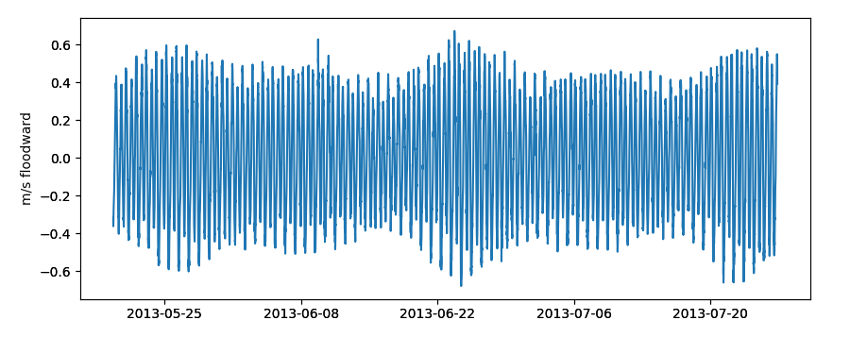

And location of the ADCP and tide gage:

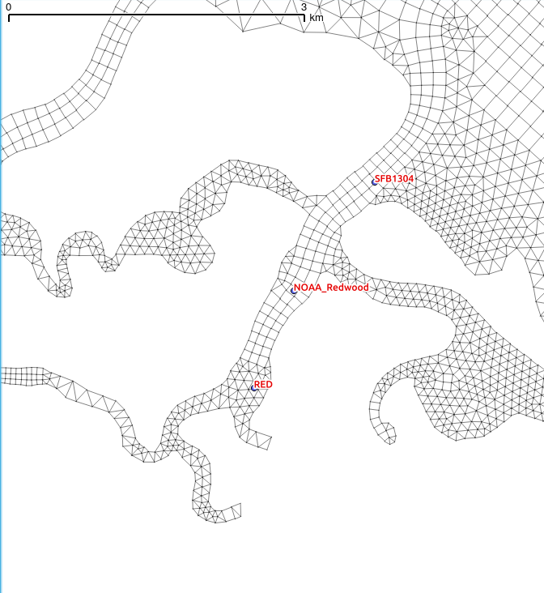

SFB1304 is the ADCP location, NOAA_Redwood is the tide gage.

## Calculations

The super rough cut would just be tidal prism for each part of that whole complex complex, Steinberger, Redwood Cr/Port, and that slough connecting them, and the tidal dead end off to the SE side.

1. Draw polygons for each of these areas, excluding known unconnected areas.
2. Note locations of breaches not captured by the DEM

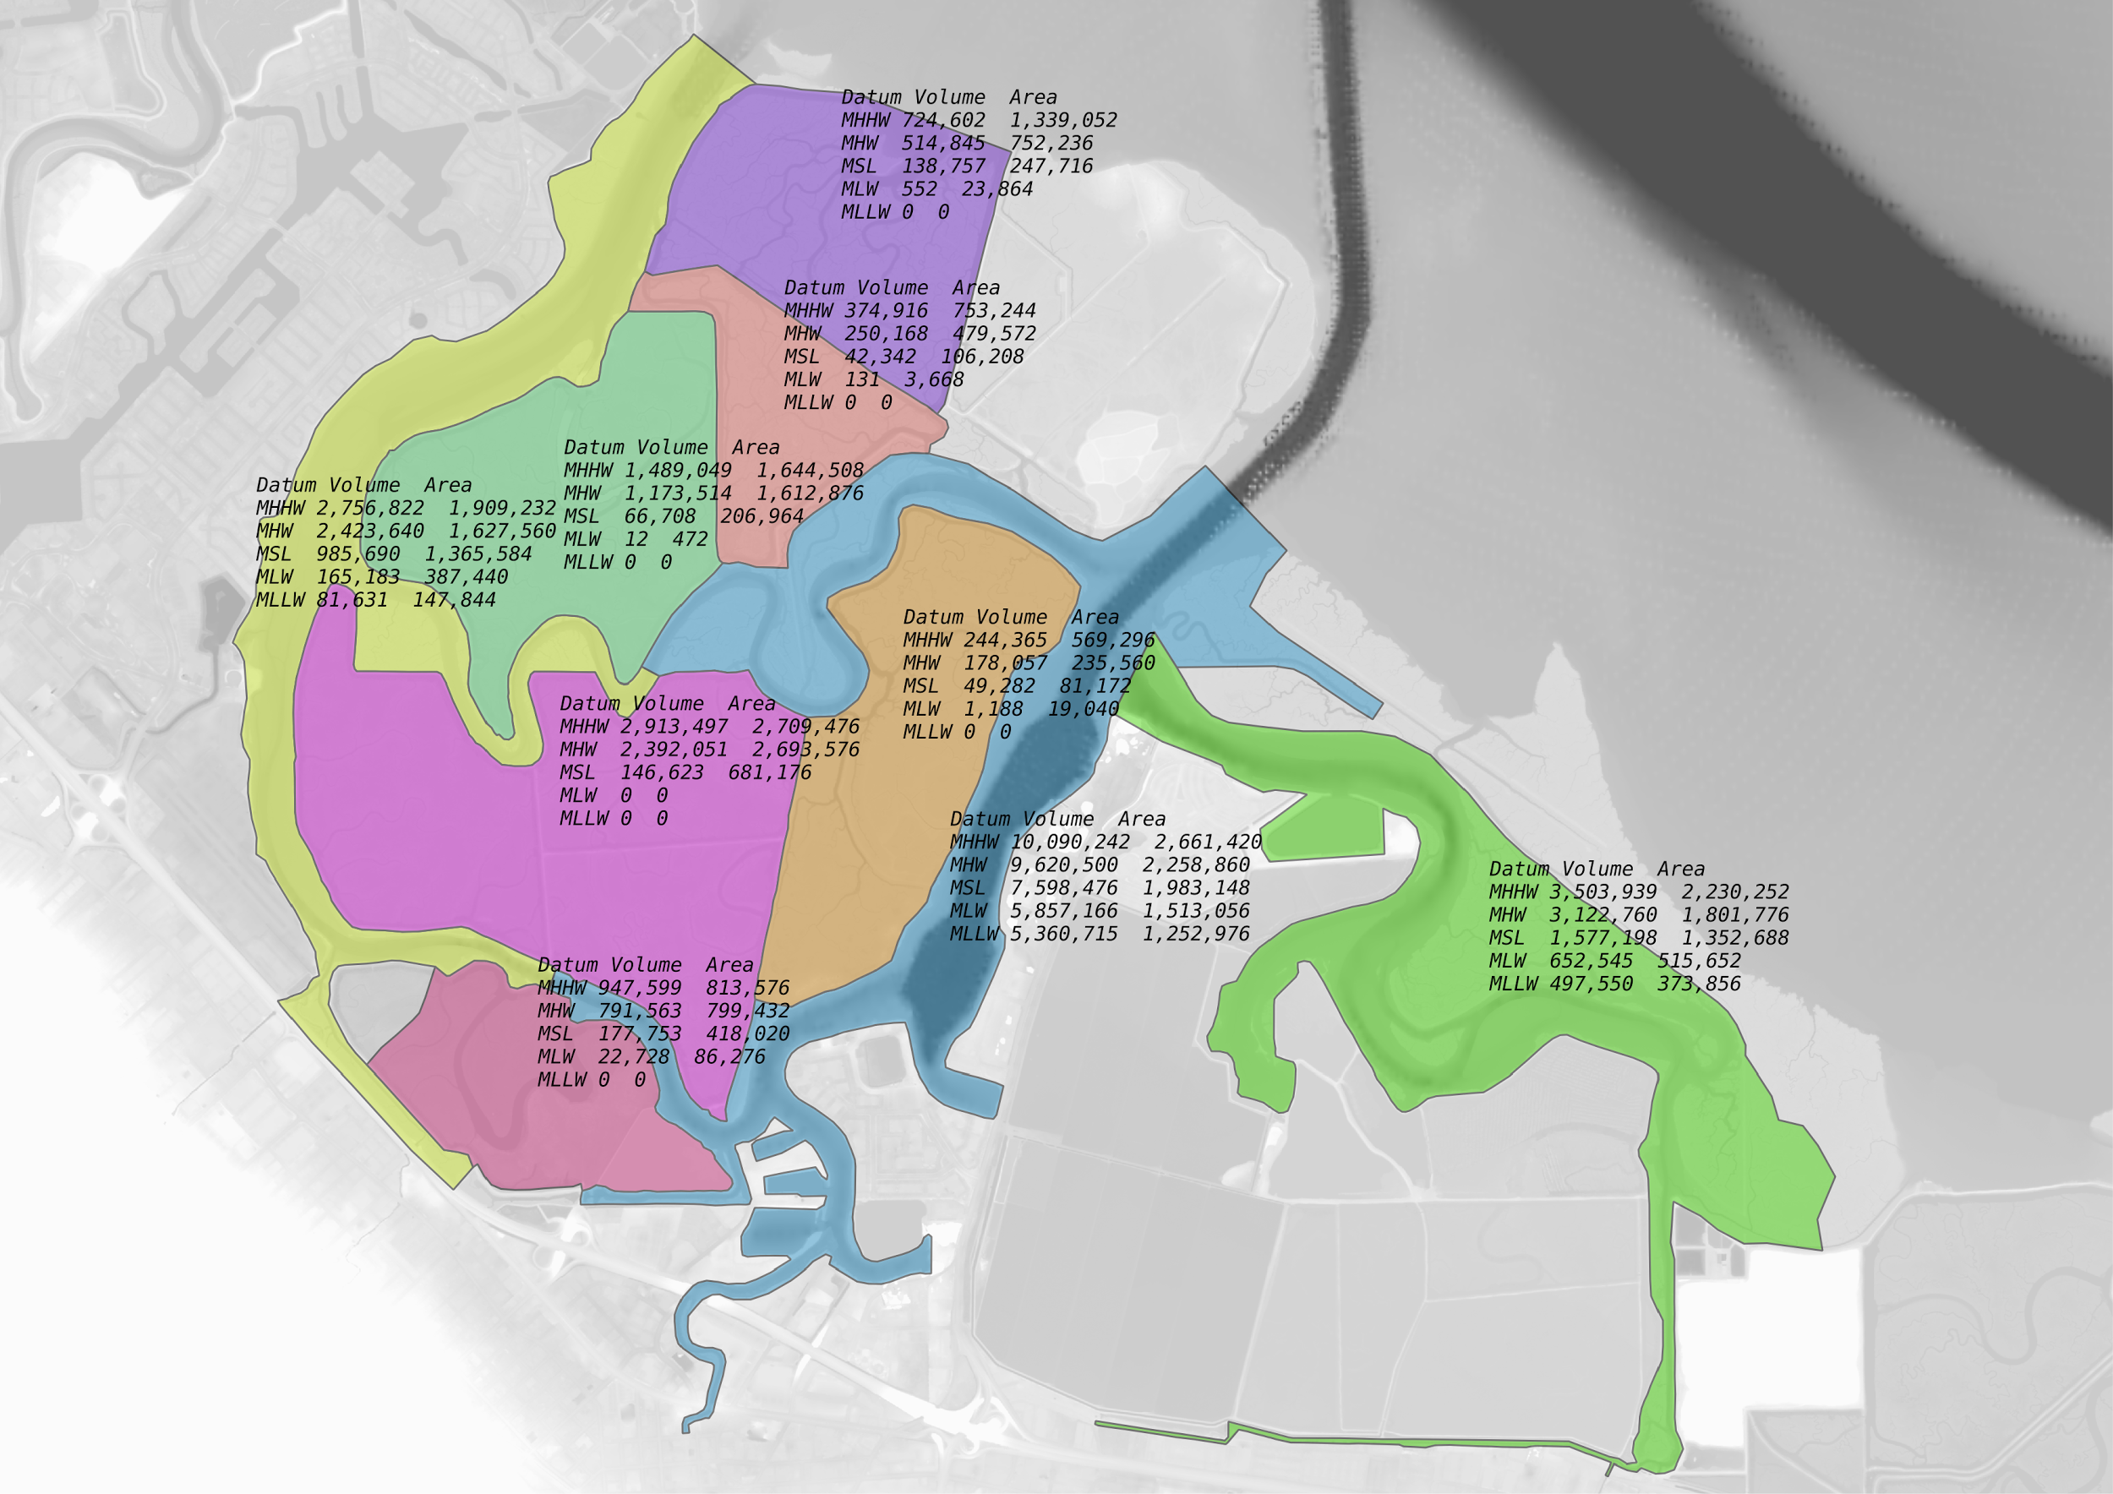

To get a sense of velocities in the channels, add up the prism for the two sides, divide by cross-section area and 6 hours to get a mean tidal flow.

Redwood:

Blue, green, orange polygons ⇒ in millions

10.09 - 5.36

.24-0

3.50-.50

⇒ 7.97e6 m3 tidal prism

The the “Profile Tool” in QGIS, the cross-section coming into Redwood Creek looks like this:

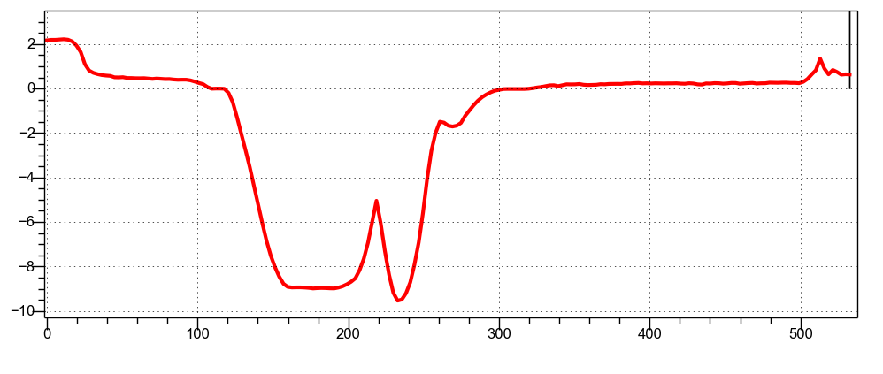

Integrating the area below MSL, get 1401 m2.

Calculating a tidal velocity scale:

$U_{tidal}≈\frac{V_{MHHW}-V_{MLLW}}{A_{channel}T_{tide}}$

which comes out to 0.26 m/s in this case. For a sinusoidal tide, that mean value would work out to max tidal velocity pi/2 greater, or 0.41m/s. This compares well with the ADCP data above – the ADCP data should be biased a little higher since it is a center-channel measurement, and this estimate is cross-sectionally averaged. At the same time, the ADCP measurement reflects frictional effects, which would tend to “square” the tides. Regardless, the numbers are a good indicator that there are not gross errors in the prism calculations.

For the Steinberger side,

Yellow, rose pink, sage green, magenta, and that southern most chunk of pink.

2.76 - 0.08

0.37-0

1.49-0

2.9-0

0.95-0

⇒ 8.39e6 m3

From the DEM, Steinberger has a much shallower channel, which makes sense given the lack of dredging and active port. The assumptions on accessible tidal prism give it more volume, though, and the velocities at the mouth of Steinberger come out to 0.86 m/s mean, 1.35 m/s max, which sounds pretty high.

There is probably some field data, related to [this](https://books.google.com/books?id=HC83AQAAMAAJ&pg=PR74&dq=steinberger+redwood+smith+slough+pwa&hl=en&sa=X&ved=0ahUKEwjU6IKOo_HYAhUH1mMKHdsgAVwQ6AEIJzAA#v=onepage&q=steinberger%20redwood%20smith%20slough%20pwa&f=false) report and PWA work, which would shed more light here. They do say that drainage divides are just south of Corkscrew Slough, and approx. 3000 feet into Corkscrew slough. That could shift at least 2e6 m3 of prism to Redwood Creek, and depending on assumptions of the plumbing of those sloughs, as much as 3.9e6 m3.

At that upper bound, the currents are nearly balanced, with Redwood mean velocity of 0.39, and Steinberger mean velocity of 0.46 m/s.

## Stormwater

Our main question would be how far out new inputs could potentially get carried - minimum distance would be the 3-4 hrs centered around a high slack. Maximum distance would be?

If Alicia got you the stormwater input locations and stormwater volumes & rate/duration for a number of storm sizes, could you plot out travel distance for different sized events ? (1, 2, 5, and 10 year return interval storms for example).

The larger events tend to max out in intensity not much different from the frequent interval events, mostly that they just drag out longer at the same intensity.

I think the idea is, for each of [X] input locations, and [1:1,1:5,1:10] events, estimate how far new inputs could get. This of course depends on the tidal stage. A simple conceptual model of the storms is that flow rates have similar magnitudes, but duration scales up with longer recurrence interval events.

### Input locations:

[Spreadsheet from Alicia](https://drive.google.com/a/sfei.org/file/d/1XLzvhazTiivFqvNzwzJSvCjQmTM-ctOa/view?usp=drive_web), [folder](https://drive.google.com/open?id=0B_UzNf5CKd6AdDdPUzVyaExTN0E)

Appear to be [six relevant watersheds](https://drive.google.com/drive/folders/0B_UzNf5CKd6AdDdPUzVyaExTN0E)

1. Atherton Creek – 15.99 m3/s YES
2. Bayfront Park – 0.38 m3/s YES
3. Cordilleras Creek – 10.12 m3/s
4. Pulgas Creek – 9.70 m3/s YES
5. Redwood Creek and Arroyo Ojo – 26.67 m3/s YES
6. Redwood Shores Lagoon – 3.63 m3/s YES
7. *SMC_unk15 – 3.44 m3/s*

And durations of 3 hours, 6 hours, and 7.3 hours for the 1:1, 1:5, and 1:10 floods.

E.g. Atherton Ck, 161g/yr annual PCB load. Load in 1:1 year storm low 7.4g, high 8.4g, so I just use the mean of that range (7.9g) / 161g = 4.9%, multiply by annual runoff vol 3,524,209m3 and get 172927m3?

Where should these enter?

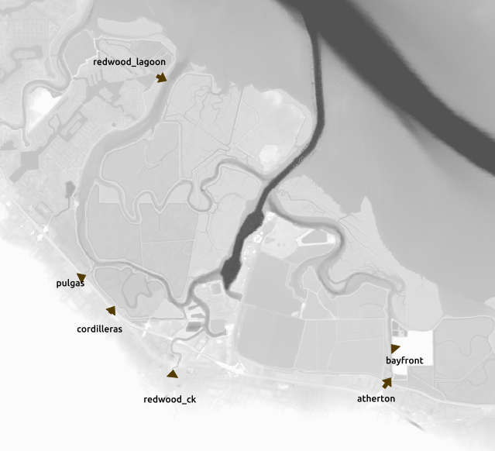

How to model this?

A: Assume no advection, no freesurface gradient, just everybody drains to deeper neighbor? Local minima will be a problem. That could be solved by drawing in a drainage skeleton tree if needed. Could also flood fill from the Bay side to get a first cut.

This yields a DAG of pixels. Load everybody up to some starting volume/sea level. Add whatever volume to the inflow points. Set the incremental next sea surface height. The start at the leaves of the tree, pushing or pulling volume from/to neighbors as needed.

This kind of works if it’s a 1D network. But in a channel, this will put all of the transport burden on the thalweg. For scalar advection that means that we have seriously intense tidal straining, so transport will effectively be broken.

Modify that so that the excess volume in a cell is apportioned to all neighbors with a lower order, in proportion to the depth.

B: What about a decaying tracer starting at each pour point? That would be used to set an “order” for the input filling in.

C: Direct DFM model

Wet 2m cells ⇒ 8M

Wet 10m cells ⇒ 320k Feasible, but heavy. Of course it’s 2D only.

Are any flows dynamically signifcant? Probably in the upper reaches, at least dynamic in comparison to tidal prism.

STATUS:

1. Need to push some grid commits from laptop to get grid gen back to functional.
2. return grid_gen_00.py